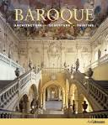
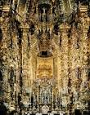
Baroque Music
Concerto Grosso/Solo Concerto
Research Task

In this homework task you are going to be exploring the Baroque Period and, in particular, comparing the Concerto Grosso to the Solo Concerto. You should include information related to social and cultural influences.

In order to pass this outcome you need to:
- Describe the social and cultural setting of the Baroque Period and how this affected the music of the time.

- Select a Concerto Grosso and a Solo Concerto and provide information about each composer and their music.

- Select a Concerto Grosso and identify instruments you hear and features and characteristics of the music.

- Select a Solo Concerto and identify instruments you hear and features and characteristics of the music.

You should take care ensuring that you have covered ALL of the bullet points mentioned above. You must also ensure that you use your own words and not copy form the internet.

You should enhance your research with pictures, extracts of music and any other relevant information.

You can access any resources from the music department or library and are welcome to use the computers at any time. Remember to use information from your folders as well as useful websites.

