SCOTTISH MUSIC RESEARCH

Throughout Scotland and the world people celebrate everything about Scotland and in the music department we want you to find out more about Scottish music. This could be traditional Scottish music or a modern Scottish band or solo artist.
In your research you are asked to do the following:

- Choose your solo musician or band
- Research of the history of the musician(s)

Where do they come from?
Who is in the band?
What do they play/sing?
What hits have they had?
What tours have they made?
Have you seen or heard the musician(s)?
What did you think of them?

In your research you must INCLUDE PICTURES.

Ensure that you use your own words – DO NOT COPY DIRECTLY FROM THE INTERNET.

You can handwrite your research OR use a computer.

YOU SHOULD INCLUDE A COVER PAGE.
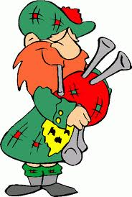

Your research should be handed in to your music teacher by the date given to you.

