Time Travel Tasks
Answer sheet 2
Name:_______________________________

Please read ‘TimeTravel Plot’ PowerPoint 2

Plot is so important in storytelling. There are so many ways a plot can twist and turn to maintain the reader’s attention and keep them interested.
Do you think that Ray Bradbury successfully does this? Before you decide, let’s look for evidence.
Annotate (label) your plot diagram with the information you gathered whilst reading the story.
* Focus on Time Travel

Plot Diagram
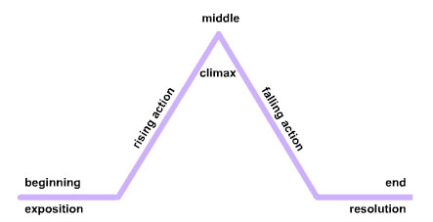
Example: https://prezi.com/0rh1lrrtoxpr/a-sound-of-thunder-plot-diagram/
Beginning – how does the story start? Setting, characters. Are there any Time travel hints and clues?
________________________________________________________________________________________________________________________________________________________________________________________________________________________________________________________________________________________________________________________________________________________________________________________________________________________________________________________________________
Rising Action – what happens, any problems, issues or conflicts to do with time travel?
________________________________________________________________________________________________________________________________________________________________________________________________________________________________________________________________________________________________________________________________________________________________________________________________________________________________________________________________________

Climax – this is the peak of the action. Everything is building towards this moment. Time travel?
________________________________________________________________________________________________________________________________________________________________________________________________________________________________________________________________________________________________________________________________________________________________________________________________________________________________________________________________________

Falling action – here the action is calming, and the story is moving towards the conclusion.
________________________________________________________________________________________________________________________________________________________________________________________________________________________________________________________________________________________________________________________________________________________________________________________________________________________________________________________________________

End – here is where the issues in the story are resolved. Have the characters learnt anything? Has the reader learnt anything? How is time travel relevant?
________________________________________________________________________________________________________________________________________________________________________________________________________________________________________________________________________________________________________________________________________________________________________________________________________________________________________________________________________

Tip – in some stories there can be more than one climax or the falling action has some ups and downs. Does this happen in ‘A Sound of Thunder’?
________________________________________________________________________________________________________________________________________________________________________________________________________________________________________________________________________________________________________________________________________________________________________________________________________________________________________________________________________
Write the name of Eckles and the name of Travis at the top of a piece of paper. Or in the middle of a spider diagram – you choose.
Looking through the story and your notes populate your notes/spider diagram with dialogue and notes about their characterisation and how time travel affects them.
This is important as it will help prepare you for your essay.
Eckles | Travis
Example:
“It can’t be killed.” Eckles realises that the beast he has so longed to kill, the very reason he has gone back in time is now a terrifying prospect and perhaps too amazing, too beautiful to kill. He understands that time travel is a mistake.

After all that plot planning and character analysis sit back and enjoy a film adaptation of the story.
This version was part of a series of adaptations of Ray Bradbury’s stories. Shown in 1989 be prepared for ‘special effects’ and a slightly blurred picture. However, it gives you a sense of the story and you can picture the characters in your mind.

Enjoy https://www.youtube.com/watch?v=VUm1rmJvl6o

Our next powerpoint will guide you through writing your essay.

